di

NHS England IA Registry Editor Tool
User Guide

Document filename: | Identity Agent Registry Editor Tool User Guide
Project / Programme | Platforms | Project | IAM
Document Reference | Identity Agent Registry Editor Tool User Guide
 |  | Status | ​​Live​
Owner | Phil Gill | Version | ​​1.0​
Author | Ashley Harris | Version issue date | ​​26/02/2024

Contents
Document Purpose 3
Overview 3
Important Information 3
Registry Editor Tool v2.1 3
Using the Tool 5
NHS England Staff 6
Further Information 6
User Profile 6
Options Selection 6
Operating System Architecture 8
Registry Details 8
Registry Example 9
Support 9

Document Purpose
This document is intended to provide general guidance on the use of the IA Registry Editor Tool.
The tool is designed to be simple to use but does require the user to have administrative rights on the machine for it to work.
Alternatively, please contact the National Service Desk using one of the following methods under Support

Overview
Spine provides the infrastructure that enables increased patient safety, improved quality of healthcare, greater clinical effectiveness and better administrative efficiency.
To gain access to various Spine Environment and 3rd party applications, users are required to switch the registries on their local machine which can be used by the installed Identity Agent to point to the correct environment for the task being performed. In many cases if these registries are missing or incorrect, this can cause problems with authentication itself.
Currently we have two ways of updating registries to point to the appropriate environments:
- Update manually with admin rights
- Use the existing IA config tool which requires admin rights to install and does not support all versions of Identity Agent
The proposed solution is to give use a very basic user-friendly tool which can be run by the end-user without any complexity and easily fulfil their requirements. The current tools available do not support all the current Identity Agents. The new IA Registry Editor Tool supports only NHSD IA v2.x (all versions).

Important Information
Please be aware that if your Trust controls the Identity Agent registry via policies, you will need to refer to your local ICT department to change the environment you are trying to authenticate against.
Refer to the Identity Agent Administrators Guide on the DIR website at:
https://nww.digital.nhs.uk/dir/downloads/NHS.England.Identity.Agent.v2.4.5.0.Administrators.Guide.Issue-1.0.zip

Registry Editor Tool v2.1
This release of Registry Editor Tool have following updates:
- Removed Unwarranted Identity Agent options for setting up registry.
  - HSCIC IA v1.x
  - BT Identity Agent v13
- Single Registry Editor tool for admin and non admin users.
- Added additional option for user to select following registry path where registry need to apply:
  - HKLM Path
  - Policy Path
  - HKCU Path
- Auto Restart Identity Agent after successful registry update.
- Updated LaunchAppsPath values for PTL environments
- Added new Registry key option:
  - TrustedCertificateIssuers
This key will only added for Live and INT environment.
- Additional information message on registry settings for HKCU and HKLM
  - HKLM
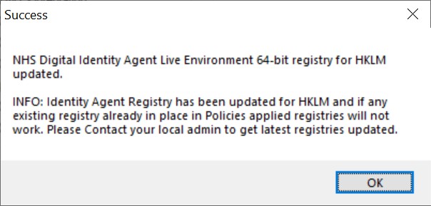
  - HKCU
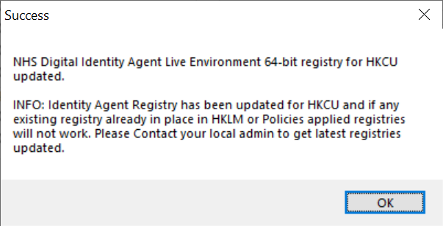
- Showing Registry Path based on selection
  - 32-bit Operating System:
    - (Policies) Group Policy: HKLM\SOFTWARE\Policies\HSCIC\Identity Agent
    - (HKLM) All Users: HKLM\SOFTWARE\HSCIC\Identity Agent
    - (HKCU) Current User: HKCU\SOFTWARE\HSCIC\Identity Agent
  - 64-bit Operating System:
    - (Policies) Group Policy: HKLM\SOFTWARE\Policies\HSCIC\Identity Agent
    - (HKLM) All Users: HKLM\SOFTWARE\Wow6432Node\HSCIC\Identity Agent
    - (HKCU) Current User: HKCU\SOFTWARE\HSCIC\Identity Agent

Using the Tool
Step 1. Run / Execute IARegistryEditorTool.Exe with Admin Rights
Step 2. Select the required Registry Path and any options if applicable
Step 3. Select the required environment
Step 4. Click on the Apply button
Step 5. Click the Ok button for the registry update success message and the tool will close
Step 6. Restart Identity Agent will be done automatically.

NOTE: The tool may appear to flicker, this is due to the program checking the state of the check boxes a few times per second. We have tried to balance the refresh time with how quickly the check boxes are updated so the tool doesn’t seem slow to respond. This is normal behaviour.
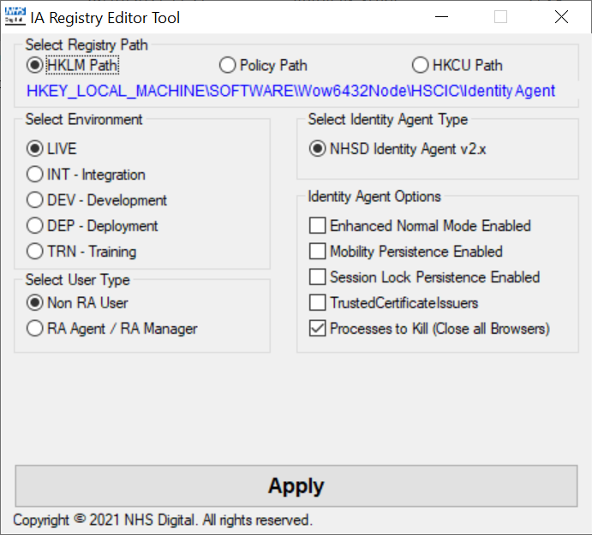

NHS England Staff
Request ICT to place the Registry Editor Tool on your desktop via Software Centre. This will allow you to use the tool without needing Admin rights to change the registry. You will need to provide ICT with the asset number and hostname of your machine. It is anticipated that soon, ICT will make the Registry Editor directly available via Software Centre.

Further Information

User Profile
The IA Registry Editor Tool is expected to be provided to and executed by NHS users. Whilst it does require an 'Admin' level of privilege to execute, the end-user in question may be blocked from running .exe files via local Group Policy. In this case, to use the tool, the user will need that constraint removing (likely by their local IT / deployment team).
If the user attempts to change the registry and they are non-admin, they will under normal circumstances be prompted for the Username / Password of an admin user. If however the machine does not have UAC enabled and the user tries to update the registry, they will get the error below and the program will exit. No changes will be made to the registry.

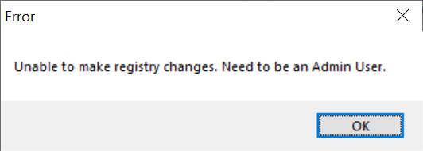

Options Selection
When the tool is launched, the user will be presented with the application window as shown in the screen shot below.
By default, the tool will update the registry with the settings for Identity Agent v2.x with the following config.
- Registry Path – HKLM (All Users)
- Authenticate against the Live environment
- Identity Agent Type – NHS England IA v2.x
- Close all browser sessions for IE, Chrome and Firefox when logging out of Spine
- Not set any hard-coded value for card-removal-check
- User type – Non-RA Users

The tool supports the choice of Live plus four PTL environments
1. INT – Integration
2. DEV – Development
3. DEP – Deployment
4. TRN – Training
The tool supports the use of only latest versions of Identity Agent
1. NHS Digital Identity Agent v2.x
The tool supports the setting of card removal check to be False. This is required for RA’s only and a warning is given when this setting is chosen. When selecting this option, the tool will only allow the Identity Agent to have the settings for Normal mode and all other operating modes are greyed out and set to false for NHS England Identity Agent v2.x.
The tool supports the setting of all the available modes in which Identity Agent v2.x supports. See the Identity Agent Administrators Guide for further information on these modes.
The tool will allow the user not to close all browser sessions when logging out of Spine. The user is prompted with a potential security warning when this option is selected as clinical data may be left on screen and visible to unauthorised users with this selection.
The tool will allow the user to specify certificates need to delete from personal certificate store to be consider during card removal.
The screen show below shows the tool with all options and warnings visible for completeness.
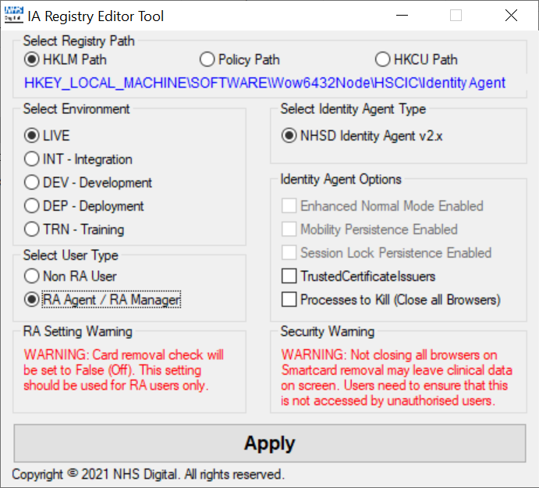

Operating System Architecture
The tool will determine the Operating System architecture of the machine automatically and update the relevant registry entry as appropriate without the user needing to know this information.
e.g. 32-bit HSCIC or NHS England Identity Agent:
HKEY_LOCAL_MACHINE\SOFTWARE\HSCIC\Identity Agent
And 64-bit is:
HKEY_LOCAL_MACHINE\SOFTWARE\Wow6432Node\HSCIC\Identity Agent
More details can be found in Identity Agent Administrator Guide
https://nww.digital.nhs.uk/dir/downloads/NHS.England.Identity.Agent.v2.4.5.0.Administrators.Guide.Issue-1.0.zip

Registry Details
The following keys will be updated in the registry based on which version of Identity Agent has been selected by the user.
NOTE: ProcessesToKill, CardRemovalCheck and TrustedCertificateIssuers will only be added to the registry when selected. All other options are added to the registry with the relevant configuration option regardless of selection where appropriate.
NHS Digital Identity Agent:
- 32-bit Operating System
  - HKEY_LOCAL_MACHINE\SOFTWARE\HSCIC\Identity Agent→ActivatePOSTURL
  - HKEY_LOCAL_MACHINE\SOFTWARE\HSCIC\Identity Agent →LaunchAppsPath
  - HKEY_LOCAL_MACHINE\SOFTWARE\HSCIC\Identity Agent→SessionLockPersistence_Enabled
  - HKEY_LOCAL_MACHINE\SOFTWARE\HSCIC\Identity Agent→MobilityPersistence_Available
  - HKEY_LOCAL_MACHINE\SOFTWARE\HSCIC\Identity Agent→LaunchAppsType
  - HKEY_LOCAL_MACHINE\SOFTWARE\HSCIC\Identity Agent→EnhancedNormalMode
  - HKEY_LOCAL_MACHINE\SOFTWARE\HSCIC\Identity Agent→CardRemovalCheck
  - HKEY_LOCAL_MACHINE\SOFTWARE\HSCIC\Identity Agent→ProcessesToKill
  - HKEY_LOCAL_MACHINE\SOFTWARE\HSCIC\Identity Agent→TrustedCertificateIssuers
- 64-bit Operating System
  - HKEY_LOCAL_MACHINE\SOFTWARE\Wow6432Node\HSCIC\Identity Agent→ActivatePOSTURL
  - HKEY_LOCAL_MACHINE\SOFTWARE\Wow6432Node\HSCIC\Identity Agent →LaunchAppsPath
  - HKEY_LOCAL_MACHINE\SOFTWARE\Wow6432Node\HSCIC\Identity Agent→SessionLockPersistence_Enabled
  - HKEY_LOCAL_MACHINE\SOFTWARE\Wow6432Node\HSCIC\Identity Agent→MobilityPersistence_Available
  - HKEY_LOCAL_MACHINE\SOFTWARE\Wow6432Node\HSCIC\Identity Agent→LaunchAppsType
  - HKEY_LOCAL_MACHINE\SOFTWARE\Wow6432Node\HSCIC\Identity Agent→EnhancedNormalMode
  - HKEY_LOCAL_MACHINE\SOFTWARE\Wow6432Node\HSCIC\Identity Agent→CardRemovalCheck
  - HKEY_LOCAL_MACHINE\SOFTWARE\Wow6432Node\HSCIC\Identity Agent→ProcessesToKill
  - HKEY_LOCAL_MACHINE\SOFTWARE\Wow6432Node\HSCIC\Identity Agent→TrustedCertificateIssuers

Registry Example
The examples shown below are using the INT environment for NHS Digital Identity Agent
- ActivatePOSTURL = "https://gas.nis1.national.ncrs.nhs.uk/login/authactivate"
- LaunchAppsPath = " https://portal.nis1.national.ncrs.nhs.uk/portal/"
- LaunchAppsType = "files"
- SessionLockPersistence_Enabled = "False"
- MobilityPersistence_Available = "False"
- EnhancedNormalMode = “False”
- CardRemovalCheck = “False”
- ProcessesToKill = “temp.exe”
- TrustedCertificateIssuers = “CN=NIS1_SUBACC, OU=CA, O=nhs;CN=SubCA02, OU=CA, O=nhs, CN=NHS INT Level 1C,OU=CA,O=nhs, CN=NHS INT Level 1D,OU=CA,O=nhs”

Support

For further support or more information, please use one of the following:
Raise a ticket via the NHS Digital Customer Portal or email ssd.nationalservicedesk@nhs.net
Telephone contact 0300 303 5035
Alternatively write to:
Iamplatforms@nhs.net

